Sun | Mon | Tue | Wed | Thurs | Fri | Saturday
 |  |  |  | 1  Requirements | 2 | 3  Requirements
4 | 5  Self Defense | 6  Self Defense | 7  Self Defense | 8  Self Defense | 9 | 10  Knife Defense  BBAE @ 11:15 Inst. Meeting  Women self defense 3-5
11 | 12  Kata Requirements | 13  Kata Requirements | 14  Kata  Bunkai | 15  Kata  Bunkai | 16 | 17  Kumite  BBAE @ 11:15  Nunchaku
18 | 19  Review  &  Refine | 20  Review  &  Refine | 21  Review  &  Refine | 22 Belt testing only. No classes today | 23 | 24  Takedowns, & Jiu Jitsu  BBAE @ 11:15  Advanced Jiu Jitsu
25 | 26  Bar Requirements | 27  Bar  Requirements | 28  Kumite | 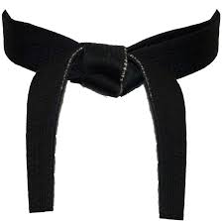  3/1  Kumite | 3/2 | 3/3  Kumite  BBAE @ 11:15  *Mandatory Inst. Meeting*

